# CS 255 System Design Document Bailey

## UML Diagrams

### UML Use Case Diagram

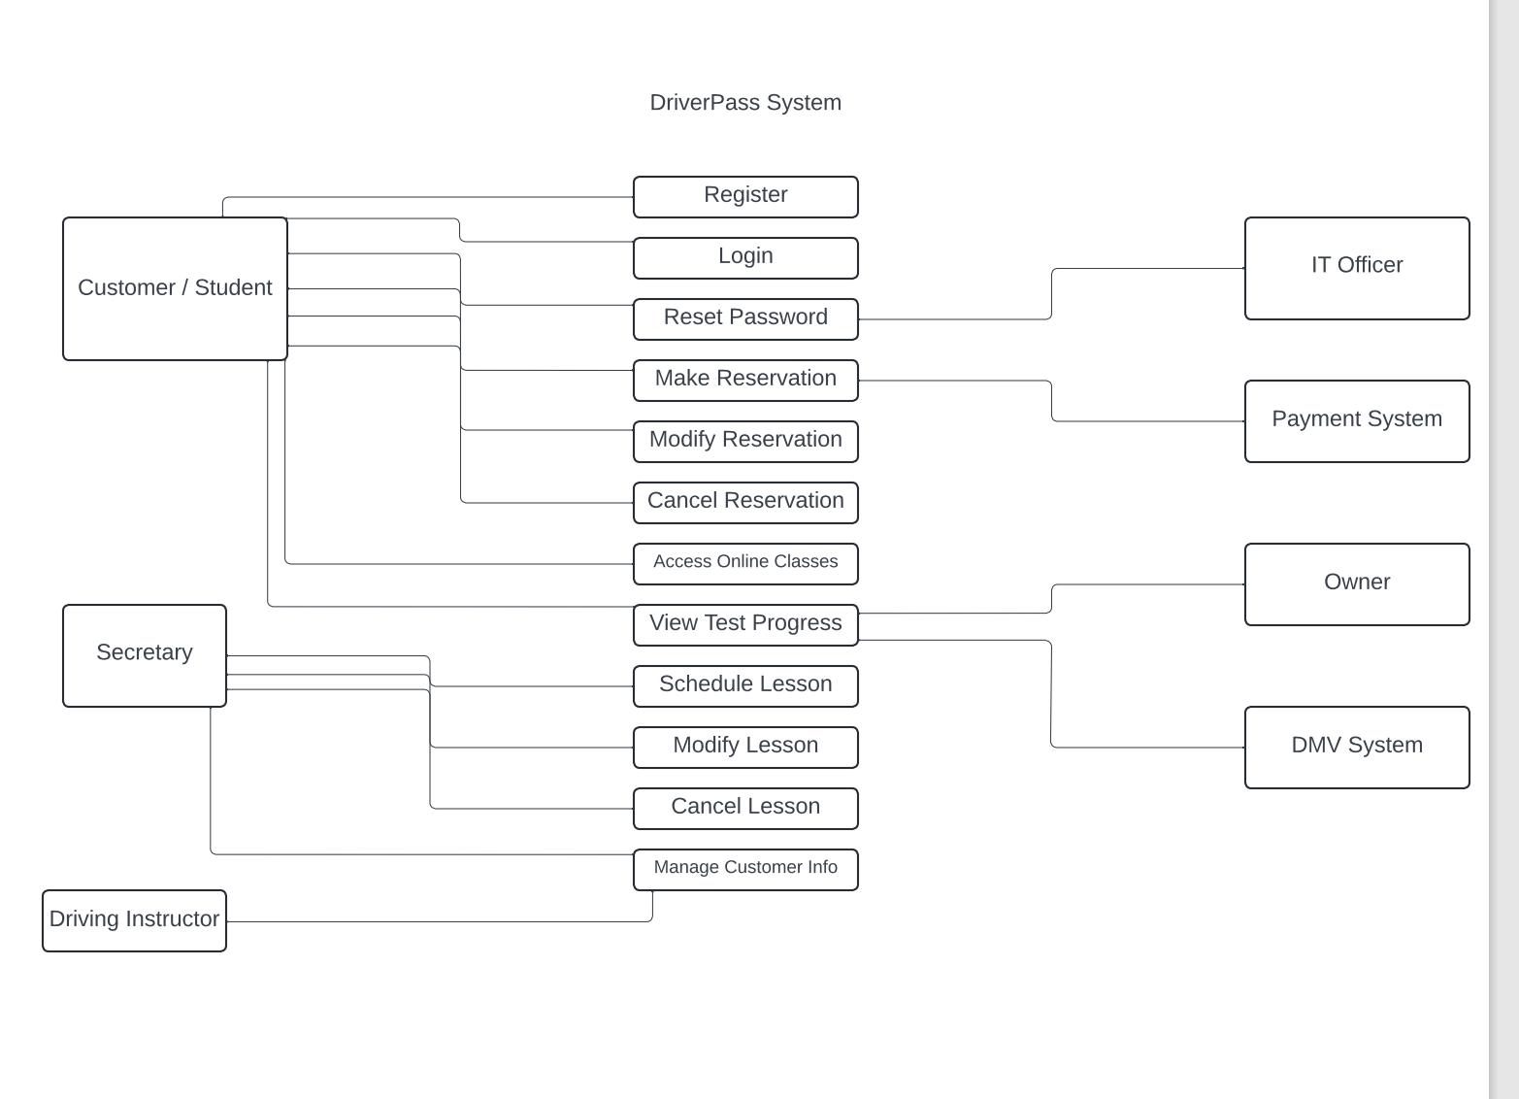

### UML Activity Diagrams

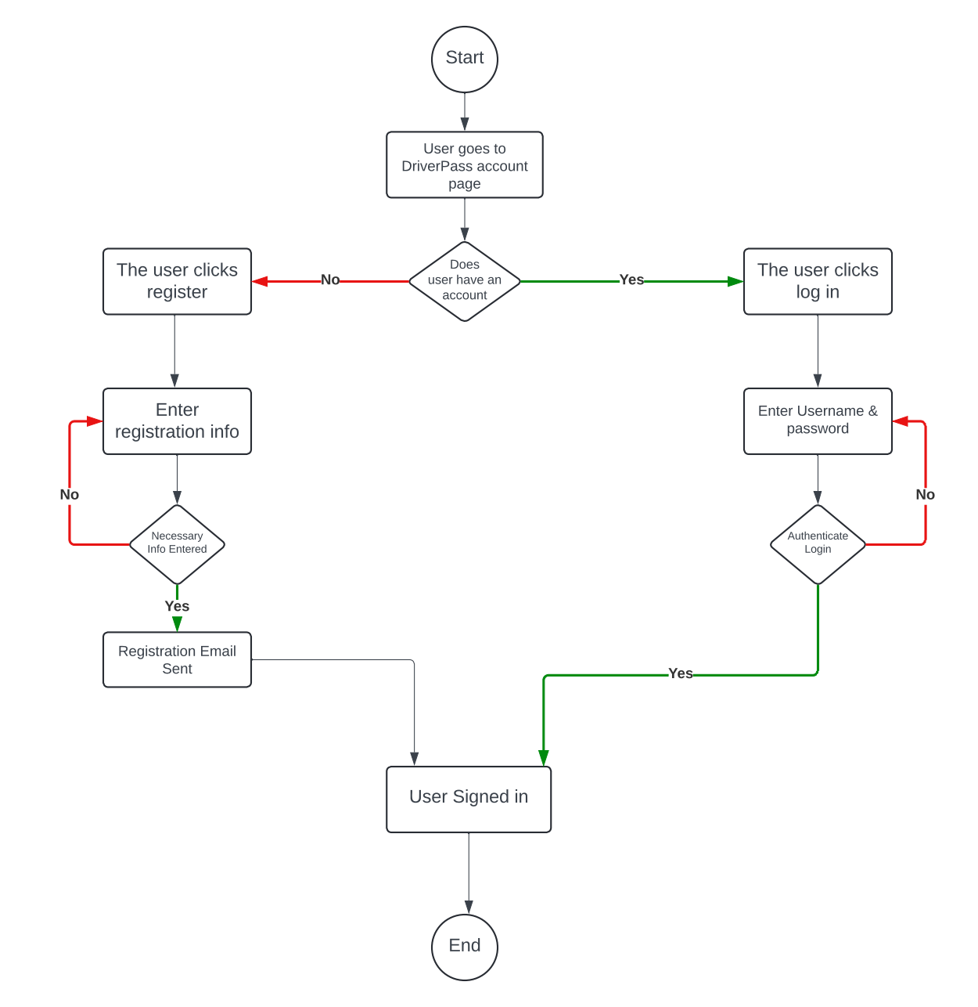

### UML Sequence Diagram

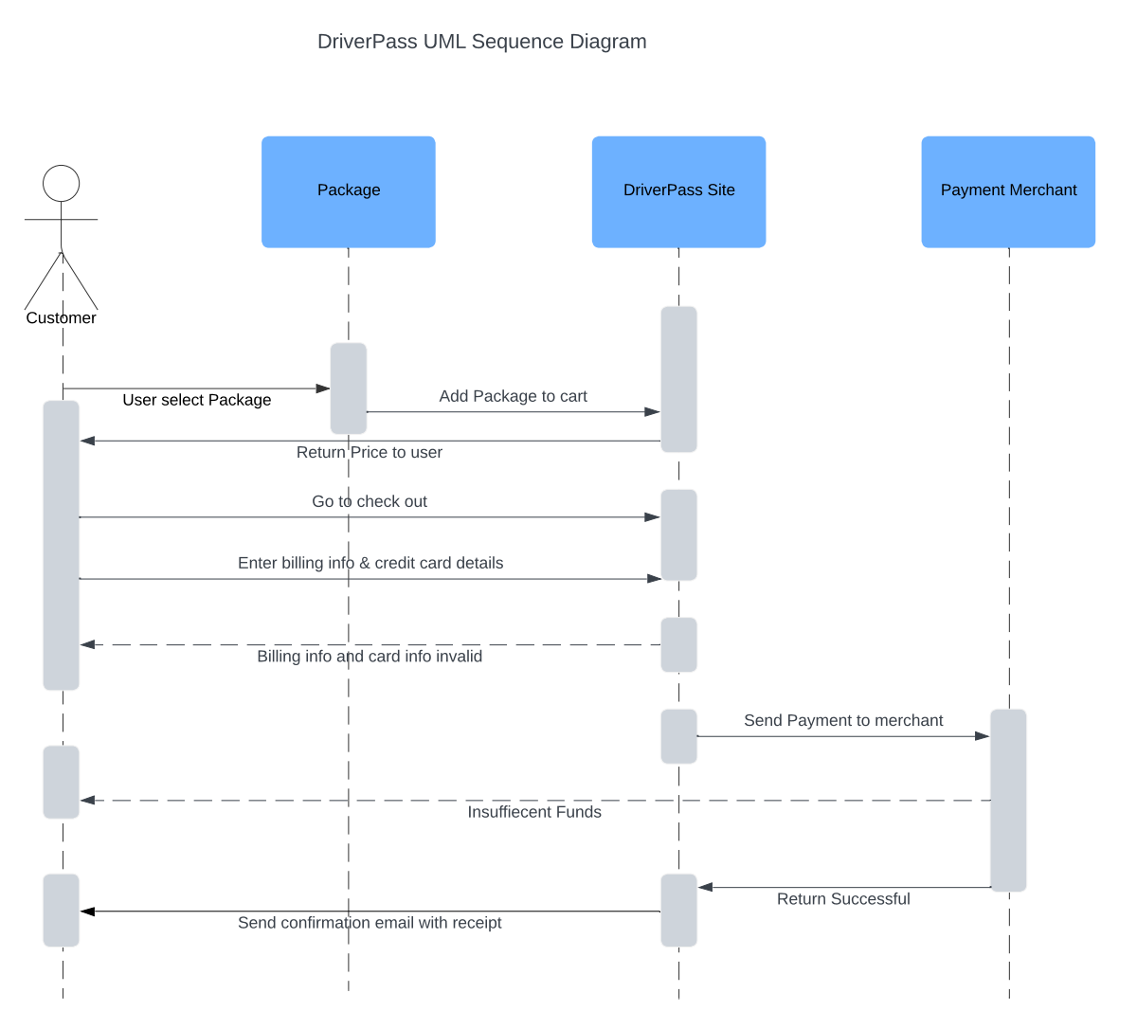

### UML Class Diagram

## Technical Requirements

* *Hardware*
  + *Firewall to be able to secure the ports*
  + *Dedicated server*
  + *Storage or website data and database*
  + *Reliable internet connection*
  + *Mobile devices / computers for the user to access the website*
* *Software*
  + *Security software / firewalls for malware protection*
  + *Web server (Apache recommended)*
  + *Operating system service (Window recommended)*
  + *Software to backup database & website data*
  + *Server for database (SQL recommended)*
* *Geographical Information*
  + *Accessibility of the website for the United States*
  + *Centralized location for the server*
  + *Data center to secure the server/ servers for the website and database*